Branding Community
  - A Case Analysis of Starbucks
Table of Contents
Introduction 3
Brand Community Identification 3
Issues related to the creation and sustaining the brand community 5
The narrative surrounding the brand 6
Identify and evaluate the potential inter-brand brand relationships and their impact 6
Importance of the shared consciousness, rituals and traditions, and a sense of moral responsibility 7
Interaction of consumers with the brand name, logo, language, stereotypes and culture perceptions, and another aspect of the brand in terms of their membership of the brand community 8
The role of perceived benefits in marketing communications 9
Conclusion 9
References 10

Introduction
Branding is a significant marketing activity that has gained significant momentum in the contemporary business environment (Schau, et al., 2009). It is mainly because companies today operate in a highly turbulent environment that is affected by factors like globalisation digitalization and dynamism. A strong branding approach assists companies to not only withstand competitive pressures but also emerge as a leader amidst such intense competition (Kao et al., 2016). Companies are on investing heavily on being innovative to stay ahead of the competition. One such innovative approach that companies today have started resorting to is developing and maintaining brand communities. Especially after success stories of companies like Harley Davidson wherein brand community was to a larger extent responsible for organisational survival and success it has attracted the attention of many companies and thus needs to be explored (Baskin, 2013).
The primary intention of this study is to explore one such brand community. With online branding community taking over traditional approaches, this study makes an effort to study the issues and significance of online branding community of Starbucks. The study focuses on different aspects related to the brand community of Starbucks which is title as "My Starbucks Idea" thus collecting information about its rise and success. The study also attempts to derive the perceived benefits that are experienced by companies my resorting to branding community as a form of marketing communication which is ultimately followed by a conclusion to the study. In this last section, certain suggestions related to the topic under study is put forward which might assist Starbucks to refurbish its approach and be more successful in the long run.

Brand Community Identification
A brand community is a social networking platform that is used by an organisation or a brand to promote itself as well as develop a wide network of people having shared feelings. The basic essence of brand communities to encourage customer participation and engagement. Though brand communities have in existence for quite some time they caught attention in recent times with booming internet and social media networking (Algesheimer, et al., 2005; Brodie, et al., 2013).
One of the examples of such brand communities which has been shaping the brand success is “My Starbucks Idea” (Brenner, 2017). This is an online brand community which provides an opportunity to the consumers especially the fanatics of Starbucks to put forward their ideas and discuss the same. the ideas shared in this medium are open to appreciations as well as criticisms thus enriching the overall idea. These appreciations and criticisms are given by other community members in form of votes. The overall experience of being a part of the brand community make the consumer feel important. Once the ideas are enriched, the ideas chosen by Starbucks for practical execution are applauded and the customers are notified through the social media platform. This helps Starbucks to continue to motivate its customers to share ideas on this platform.
The brand community of Starbucks which started in 2008 today has more than 150,000 members for whom this approach is based on the customary philosophy of a box for suggestions (Gembarski, 2012). Starbucks not only promotes consumers to participate in idea generation but with the help of its Partner Team ensures that the best idea is modified and put into practice. The company has implemented a series of improvements ranging from availability of WI-FI services free of cost to consumers, introduction of new products like peach green-tea lemonade, Cake Pops and Hazelnut Macchiato (Harvard Business School, 2015). Within 5 years of setting up the brand community, the company was able to generate more than 150,000 ideas. From these, it adopted more than 250 ideas too (Harvard Business School, 2015).

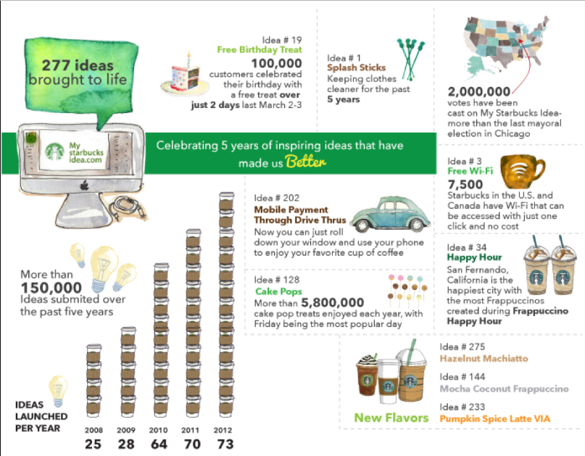
Figure 1 My Starbucks Idea
Source: (Harvard Business School, 2015)

One of the primary benefits of this platform to Starbucks is that it helps the company to comprehend the needs of its target consumers. It also assists in keeping a track of alterations in consumer preferences as well as analyse their motivational factor. The company through such an approach has been successful over the years and triumphed over hurdles without major hiccups (Tybout & Calder, 2010). The overall approach adopted by Starbucks for branding community and its management is very simple for all the stakeholders thus making it convenient for the consumers to participate.

Issues related to the creation and sustaining the brand community
While creating a brand community, it is important for a company to understand that these communities provide a platform for interaction and communication with the target consumers. Problems arise while creating such communities when companies tend to treat this platform as one for generating business (Terechshenko & Radionova, 2011; Fournier & Lee, 2009). Though such communities result in the creation of loyal consumers it is not necessary that it would result in growth in organisational profitability and revenues. One of the primary objectives of creating and sustaining brand communities is to ensure that the consumers or general public related to a brand is being served without expecting any monetary outcome in return. For this, it is important for companies to work dedicatedly in supporting brand communities. The company might have to bring about changes within its existing culture which is a stringent and difficult activity. One successful example is that of Starbucks who brought in extensive changes within its organisational framework to support brand community but not necessary all organisation experience similar benefits and thus cautious efforts needs to be resorted to (Schau, et al., 2009). Thus, for effective brand community creation and nourishing it for long run benefits it is important for all the functional departments of an organisation to operate dedicatedly though coordinated efforts which are a challenging activity (Podnar, 2015).

Amongst all the issues in sustaining a brand community one of the most significant ones is the management of these communities. These communities are not assets of the company and thus it is difficult for them to closely and strongly manage and control activities within communities (Fournier & Lee, 2009). For example, there are brand communities like anti-Starbucks which are defaming the brand and the company (Hollenbeck & Zinkhan, 2010). Though measures are undertaken by the company to exercise a certain level of control it is a mere misapprehension because brand communities are controlled by external forces which are beyond organisational reach.

The narrative surrounding the brand

Starbucks has an age-old history but since its inception, it has dedicated itself to serve the people and community as a whole. The company irrespective of hiccups faced has been progressing beyond leaps and bounds but in the year 2008, once the economic recession was faced by the world at large, Starbucks was also adversely affected (Wiggins, 2008). This made its survival difficult thus forcing the company to look for innovative approaches to overcome such a mammoth problem in hand. The online branding community was thus an approach to deal with the repercussions of economic recession as well as restore lost confidence of its consumers (Cabiddu, et al., 2012). The company through its online branding community made attempts to make its consumers feel valued and thus respected their thoughts shared over the common platform (Cabiddu, et al., 2012; Wiggins, 2008).

The My Starbucks Idea thus emerged as a platform where not only the consumers interacted with the company but also interacted with other members on the platform (Hossain & Islam, 2015). Therefore, this acted as a strong social hub for people from all across the world to interact and socialise hence assisting the company to meet its vision through shared values.

Identify and evaluate the potential inter-brand brand relationships and their impact
Once a consumer is exposed to a brand which it finds to be interesting then he or she is motivated to collect more information about the same. One of the factors that have the most significant impact on a consumer is the association of a brand with the other which is termed as an inter-brand relationship. With inter-brand relationships comparison between brands becomes more informational for a consumer thus directing their behaviour and assisting them to take their call for the brands. Upon comparison between brands, the brand for which wider range of information is available wins over the other.

Starbucks, as an organisation though does not, has strong relations with other brands but it resorts to approaches that boost the growth of its own brand and thus form a part of its brand architecture.

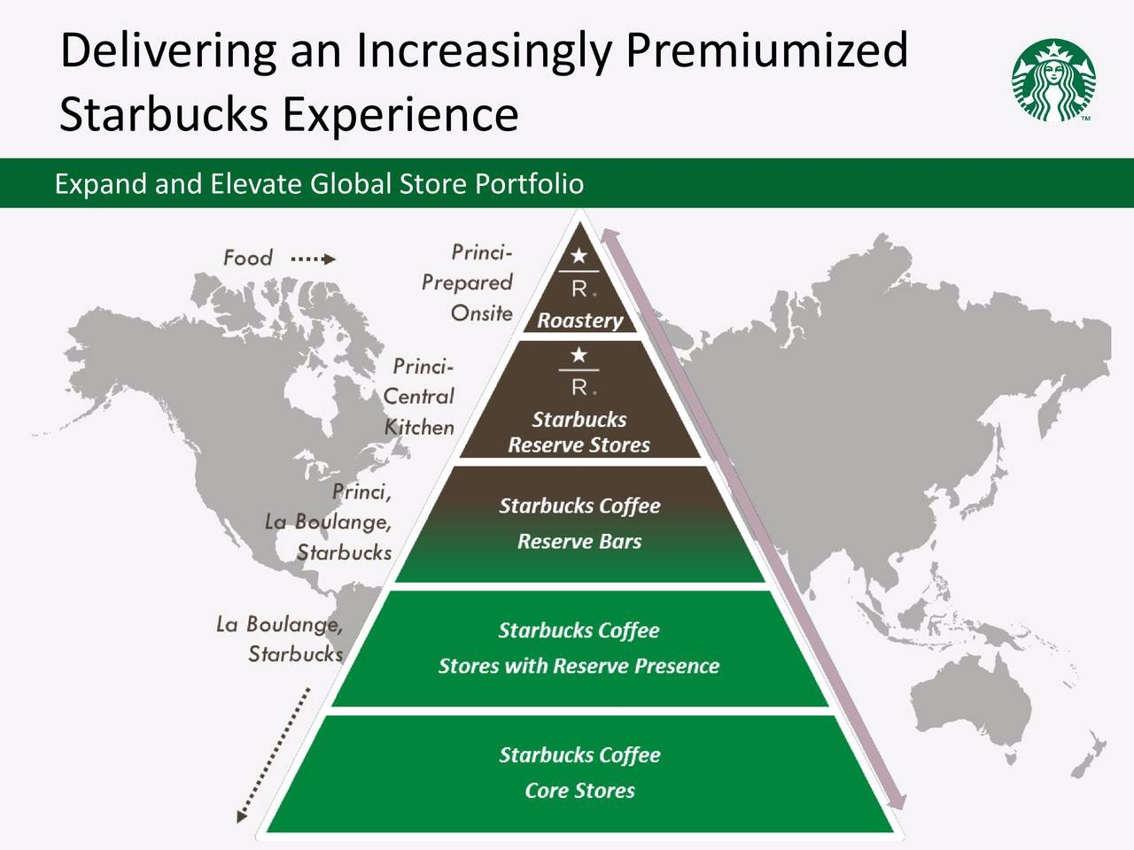
Figure 2 Starbucks: Inter-brand relationships and Brand Architecture
Source: (Taylor, 2016)

Along with this inter-brand relationship over social media exercised by Starbucks is very strong. The growth of the company across social media platforms especially Facebook and Twitter is an example of the same. Such relationships have assisted Starbucks to nurture itself and emerge as a powerful brand within its industry (Fournier & Lee, 2009).
The potential inter-brand relationships have a strong impact brand attitude and in turn influence evaluations of the brand. As inter-brand relationships depict a broader picture of the market it assists is the creation of value that is intangible in nature and thus provides for greater benefits to the consumers (Stieler, 2017).

Importance of the shared consciousness, rituals and traditions, and a sense of moral responsibility

Shared consciousness means the perception of members about the brand community (Zaglia, 2013). It is the shared consciousness amongst the members of Starbucks branding community which assists them to stay together in a connected format. The members of Starbucks differentiate themselves from the others especially the non-members. A sense of being in the right place is developed amongst the members of the brand community (Zaglia, 2013). Further, it is with the help of this shared consciousness that a feeling of categorisation on a social platform is being created which makes it possible for the group members to compare themselves with others.

Rituals and traditions comprise of sharing of experiences over the community platform thus creating histories. These experiences over a period of time get associated with the brand history and values thereby setting examples and creating behaviour. The rituals and traditions of Starbucks which is primarily formed owing to its consistent approach and behaviour towards its customers globally make the experience of consumers impactful (Ozlek, 2015). These experiences triggered by one’s personal emotion when shared over social media platforms embeds the ritual and tradition and thus assigning meaning to the brand community. Over the branding community of Starbucks, people are motivated to share stories about people and not the products offered by the brand (Gallo, 2017). Storytelling is a legacy over the brand which is evident from the stories shared by its executive chairman that is Howard Schultz and the same has been ingrained in its branding community (Gallo, 2017).

Moral responsibility in branding communities implies accountability of the members of the brand community and the brand itself towards each other (Zaglia, 2013; Muniz & O’Guinn, 2001). In the case of Starbucks, both the company as well as the members of the brand community share mutual relationships towards each other. For example, on one hand, the consumers interact and put forward ideas for improvisation to the company which is acknowledged by Starbucks. Once the idea is being accepted the members involved in providing the same and those involved in improving it are publicly applauded and recognised. This creates a sense of pride among the consumers thus motivating them to be more active. Members also fulfil their moral obligations by adding new members to the community thus increasing the size of Starbucks fans.

Interaction of consumers with the brand name, logo, language, stereotypes and culture perceptions, and another aspect of the brand in terms of their membership of the brand community

One of the fascinating factors about Starbucks is its consistency which is also passed to its customers while interacting with them over the branding community. This consistency is evident in every aspect Starbucks right from its logo till its culture (Roll, 2017). The branding community of Starbucks aims at creating an experience similar to its approach in the stores. This culture of Starbucks has motivated consumers to establish higher levels of interaction over branding community. The logo of the company has been considered as one of the most discernible ones across the world. The basic logo of the Siren has been the same but with changing times multiple aspects have been added to the logo which not only hints the consumers about the changes but also raises their curiosity (Roll, 2017). This triggers their interest in branding communities.

The role of perceived benefits in marketing communications
In marketing communications, the role of perceived benefits is quite significant as it assists the marketer in undertaking decisions with regards to the communication channel. Within the social media or the digital media forum some of the most important perceived benefits that the marketer seeks to avail through marketing communications are collection of information, following-up movements of competitors, collection of information about consumers, gaining knowledge about creativity and innovations, sharing of knowledge, interactions with consumers, raising awareness, enhance communication within organisation, swift response towards requests and grievances, enhanced communication with organisational stakeholders like vendors, keeping a tap of conversations over social media platforms, search for employees and their recruitment and ultimately socialise (Tiago & Veríssimo, 2014)

Conclusion
Branding community has proved to be a strong marketing tool in the case of Starbucks. The company has been effectively using it and thus steeping ahead competition irrespective of hindrances. Though the branding community has resulted in significant outcomes but yet measures can be undertaken to improve upon this approach which will assist Starbucks in deriving maximum benefits. One of the suggestions is that Starbucks should provide for monetary benefits to its customers who share quality ideas that are beneficial for the company. These monetary benefits would motivate consumers to share more idea thus resulting mutual benefits. It is also recommended that Starbucks should support the active involvement of other organisational stakeholders like vendors in idea generation. This will help Starbucks to derive holistic benefits thus realising the true meaning of branding communities.

References
Algesheimer, R., Dholakia, U. & Hermann, A., 2005. The social influence of brand community: evidence from European car clubs. Journal of Marketing, Volume 69, p. 19–34.
Baskin, J., 2013. Harley-Davidson Will Be A Case History In Social Branding. [Online]
Available at: https://www.forbes.com/sites/jonathansalembaskin/2013/07/12/harley-davidson-will-be-a-case-history-in-social-branding/#294e99cd155e
[Accessed 19 Apr 2018].
Brenner, M., 2017. 5 Examples of Brilliant Brand Communities That Are Shaping The Online World. [Online]
Available at: https://marketinginsidergroup.com/content-marketing/5-examples-brilliant-brand-communities-shaping-online-world/
[Accessed 18 Apr 2018].
Brodie, R., Ilic, A., Juric, B. & Hollebeek, L., 2013. Consumer engagement in a virtual brand community: An exploratory analysis. Journal of Business Research , Volume 66, pp. 105-114.
Cabiddu, F. et al., 2012. Combining exploitation and exploration through crowdsourcing: The case of Starbucks. In: Information systems: crossroads for organization, management, accounting and engineering. Heidelberg: Physica, pp. 359-366).
Fournier, S. & Lee, L., 2009. Getting Brand Communities Right.. Harvard Business Review, Issue April, pp. 105-111..
Gallo, C., 2017. Starbucks' Cool New Brew: Storytelling With A Digital Twist. [Online]
Available at: https://www.forbes.com/sites/carminegallo/2017/12/11/starbucks-cool-new-brew-storytelling-with-a-digital-twist/#569a3f327735
[Accessed 19 Apr 2018].
Gembarski, R., 2012. How Starbucks Built an Engaging Brand on Social Media. [Online]
Available at: https://www.brandingpersonality.com/how-starbucks-built-an-engagin-brand-on-social-media/
[Accessed 18 Apr 2018].
Harvard Business School, 2015. My Starbucks Idea: Crowdsourcing for Customer Satisfaction and Innovation. [Online]
Available at: https://digit.hbs.org/submission/my-starbucks-idea-crowdsourcing-for-customer-satisfaction-and-innovation/
[Accessed 18 Apr 2018].
Hollenbeck, C. & Zinkhan, G., 2010. Anti‐brand communities, negotiation of brand meaning, and the learning process: The case of Wal‐Mart. Consumption, Markets and Culture, 13(3), pp. 325-345..
Hossain, M. & Islam, K., 2015. Generating ideas on online platforms: A case study of “My Starbucks Idea”.. Arab Economic and Business Journal, 10(2), pp. 102-111.
Kao, T. et al., 2016. Co-creating value with consumers through social media. Journal of Services Marketing, 30(2), pp. 141 - 151.
Muniz, . & O’Guinn, T., 2001. Brand Community. Journal of Consumer Research, 27(4), pp. 412-432.
Ozlek, J., 2015. Starbucks’ Consumption Rituals and Brand Loyalty in Relation to its Consumer’s Experience, Product Consistency, and Terminology. [Online]
Available at: https://lipsandlashdotco.files.wordpress.com/2016/02/starbucks-consumption-rituals-and-brand-loyalty.pdf
[Accessed 19 Apr 2018].
Podnar, K., 2015. Corporate Communication: A Marketing Viewpoint. Oxon: Routledge.
Roll, M., 2017. The Secret to Starbucks’ Brand Success. [Online]
Available at: https://martinroll.com/resources/articles/strategy/secret-starbucks-brand-success/
[Accessed 20 Apr 2018].
Schau, H., Muñiz Jr, A. & Arnould, E., 2009. How brand community practices create value. Journal of marketing, 73(5), pp. 30-51..
Stieler, M., 2017. Creating Marketing Magic and Innovative Future Marketing Trends: Proceedings of the 2016 Academy of Marketing Science (AMS) Annual Conference. Berlin: Springer.
Taylor, K., 2016. Starbucks' new Willy Wonka-inspired store in Tokyo offers a glimpse into the brand's future. [Online]
Available at: https://www.businessinsider.in/Starbucks-new-Willy-Wonka-inspired-store-in-Tokyo-offers-a-glimpse-into-the-brands-future/articleshow/54955806.cms
[Accessed 19 Apr 2018].
Terechshenko, M. & Radionova, V., 2011. Brand Communities: A quantitative study of brand community influence on prospective and existing members., Sweden: Umeå School of Business.
Tiago, M. & Veríssimo, J., 2014. Digital marketing and social media: Why bother?.. Business Horizons, 57(6), pp. 703-708..
Tybout, A. & Calder, B., 2010. Kellogg on Marketing. 2 ed. New Jersey: John Wiley and Sons.
Wiggins, J., 2008. The trouble with Starbucks. [Online]
Available at: https://www.ft.com/content/aa9831ce-c266-11dd-a350-000077b07658
[Accessed 19 Apr 2018].
Zaglia, M., 2013. Brand communities embedded in social networks. Journal of Business Research, 66(2-2), p. 216–223..

